Unit 3 Worksheet

Read and Write
仿照範例，將提示字做適當變化後，重寫句子，再填入圖片編號。
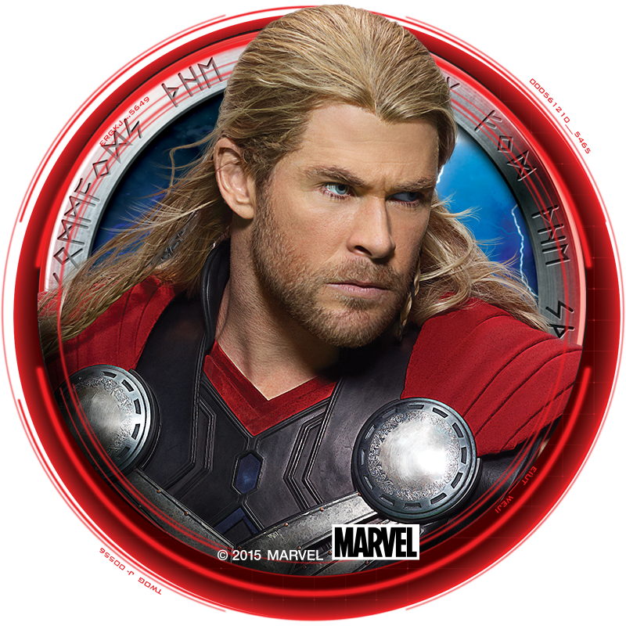
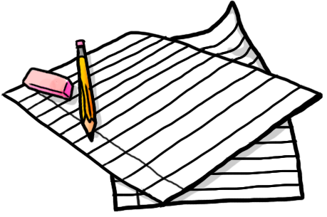
F
C
D
E



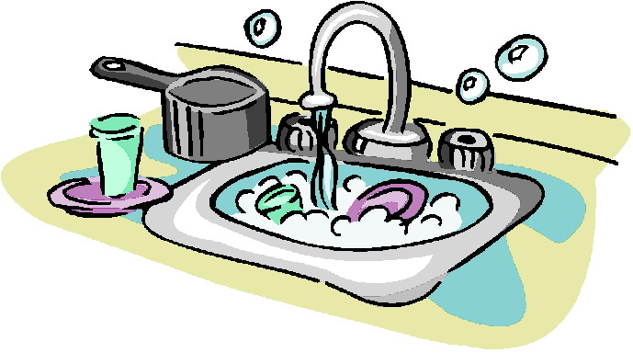



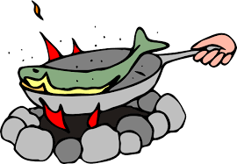


B

EX: Iron Man / wash the dishes/ yesterday.
E
- Iron Man washed the dishes yesterday.
- Hulk / water the plants/ every day.

- ___________________________________
- Thor/ do his homework/ last weekend.

- ___________________________________
- Captain America/ listen to music/ now.

- ___________________________________
- Black Widow/ clean her room/ last night.

- ___________________________________
- Spider Man/ cook dinner/ now.

- ___________________________________

